As-is Process Map
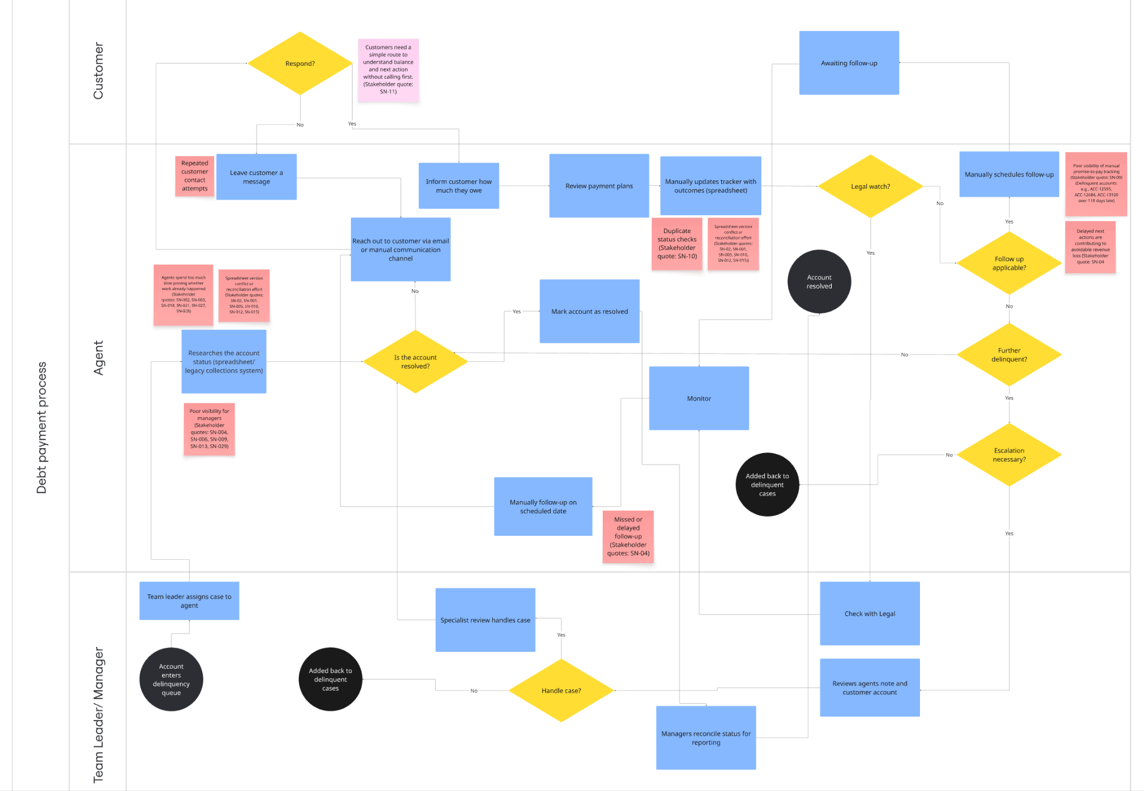

Comparison of how the process feels so far:

Customer:
The customer experiences a fragmented service that has previously forced customers to repeatedly provide account history, creating a sense of distrust in the bank’s competence. Whilst they are technically shielded from how fractured the internal system is, they are aware of the resulting symptoms, such as conflicting communications, missed follow-ups and delayed updates, which may reduce the customer’s intent to pay.

Agent:
The agent currently functions as a manual human integration layer, spending too much of their time performing low-value investigative searches across disconnected systems just to verify a case's status. The high cognitive load needed to remember a case’s status or carry out a long search leads to increased average handle time, preventing them from applying their specialised skills to high-value recovery such as working with customers which require human interaction.

Team leader/ manager:
The team leader/ manager suffers from poor visibility across multiple areas, relying on old, manually reconciled data that is out-of-date with the current status. This prevents real-time resource allocation, where high-value accounts frequently stagnate while the team is focused on low-value administrative tasks such as manual cross-referencing. They are concerned about delays and missed follow-ups contributing to the revenue leakage. In addition, the strain this causes on their team is of importance.

Suitable steps for self-service:
- Automate Payment Processing:
Enabling customers to settle outstanding balances independently is an ideal Phase 1 candidate because it is a high-volume, rules-driven transaction that requires no subjective judgment. By automating this repeatable process, we directly reduce the number of delinquent cases entering the manual queue, fulfilling the processing goal of straightforward cases (low-risk accounts). This addresses a critical customer pain point identified in interviews while simultaneously aiming to reduce the account handling delay contributing to revenue loss mentioned by finance partners.

- Automated tracker of interaction history:
Implementing a system-generated log of all customer touchpoints is a high-volume, repeatable necessity that eliminates the need for manual data entry. Because the capturing of sending emails or portal logins is rules-driven, it removes the risk of human error or missing context that would lead to agent rejection. This directly addresses the agent's and team leader’s pain point of spending too long manually cross-referencing and ensures that every customer interaction is informed by accurate, real-time history, protecting the bank’s professional image.

- Unified Customer View (SSoT):
Centralising data into a single source of truth is a critical Phase 1 candidate as it addresses the high-volume of stakeholder concerns regarding spreadsheet version conflicts. While technically a back-end automation, it is a rules-driven consolidation of data that eliminates the manual reconciliation effort currently performed by Managers. This reduces time spent on low-value manual cross-referening that leads to delayed follow-ups, ensuring that agents and customers are always looking at the same, accurate balance.

- Automated follow ups:
Automating the trigger for next steps is a repeatable, high-volume process that ensures no account stagnates in a manual queue. This is a rules-driven candidate where specific milestones (e.g., 5 days since last contact) trigger an automatic notification, removing the reliance on an agent’s memory. By eliminating the reliance on manual spreadsheet tracking, we contribute to tackling the 15% revenue leak caused by missed or delayed follow-up appointments.

- Automated Promise-to-Pay (PTP) Tracker:
Moving PTP agreements from manual spreadsheets to an automated tracker is a low-risk, rules-driven win for Phase 1. When a customer makes a promise to pay, the system can independently monitor the account for the incoming credit; if the "rule" is broken (no payment received), an escalation is triggered automatically. This solves the Manager's pain point regarding poor visibility of PTP tracking and ensures that broken promises are actioned immediately, rather than being classed as “promise due” for 120 days (ACC-13100) in the delinquent accounts spreadsheet.

Steps to keep agent-led:

- Assessing "Legal Watch" and Fraud Status: While Phase 1 can automate rules-driven triggers (such as flagging transactions exceeding £10,000 for review), the final decision remains high-risk and requires human judgment. Identifying sophisticated fraud patterns or legal grey areas requires specialist review and exception handling that cannot be automated. Keeping this agent-led ensures the bank maintains regulatory compliance and avoids false positive errors that could occur with premature automation of complex legal statuses.

- Complex cases:
High-risk accounts remain agent-led as they require judgment-heavy exception handling and specialist negotiation that rules-based systems cannot navigate. This directly addresses stakeholder concerns regarding risk and compliance, ensuring the bank’s highest-liability decisions stay with its most experienced specialists

